**General Web Application Questions**

**Single-Page Applications (SPA)**

Single-Page Applications (SPAs) are Web apps that load a single HTML page and dynamically update that page as the user interacts with the app.

In a traditional Web app, every time the app calls the server, the server renders a new HTML page. This triggers a page refresh in the browser. If you’ve ever written a Web Forms application or PHP application, this page lifecycle should look familiar.

In an SPA, after the first page loads, all interaction with the server happens through AJAX calls. These AJAX calls return data—not markup—usually in JSON format. The app uses the JSON data to update the page dynamically, without reloading the page. **Figure 2** illustrates the difference between the two approaches.

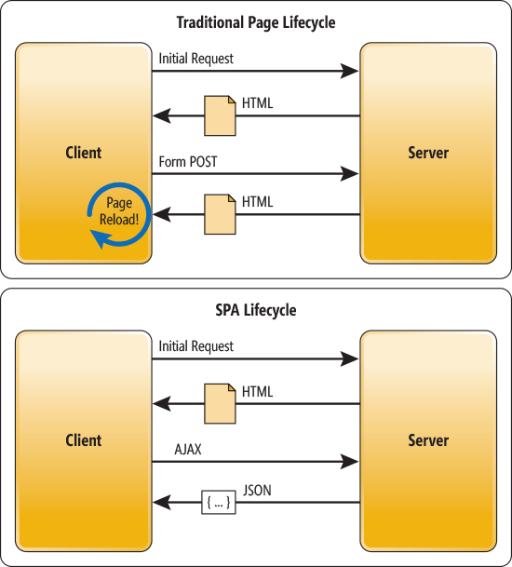   
**Figure 2 The Traditional Page Lifecycle vs. the SPA Lifecycle**

One benefit of SPAs is obvious: Applications are more fluid and responsive, without the jarring effect of reloading and re-rendering the page. Another benefit might be less obvious and it concerns how you architect a Web app. Sending the app data as JSON creates a separation between the presentation (HTML markup) and application logic (AJAX requests plus JSON responses).

## The MVC and MVVM Patterns

The MVC pattern dates back to the 1980s and early graphical UIs. The goal of MVC is to factor the code into three separate responsibilities, shown in **Figure 7**. Here’s what they do:

* The model represents the domain data and business logic.
* The view displays the model.
* The controller receives user input and updates the model.

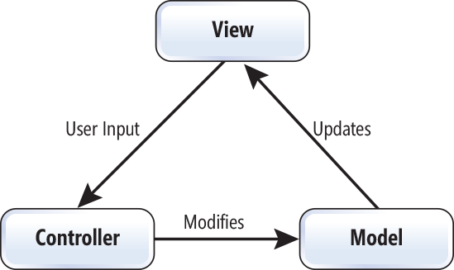  
**Figure 7 The MVC Pattern**

A more recent variant of MVC is the MVVM pattern (see **Figure 8**). In MVVM:

* The model still represents the domain data.
* The view model is an abstract representation of the view.
* The view displays the view model and sends user input to the view model.

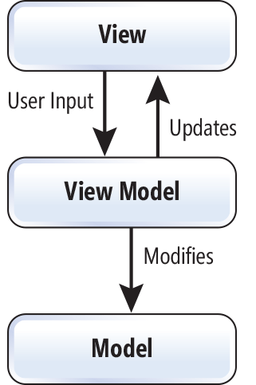  
**Figure 8 The MVVM Pattern**

In a JavaScript MVVM framework, the view is markup and the view model is code.